Adelaide Model Railway Exhibition 2026
Exhibitor Registration Form

This form may be completed on a computer or other device and saved as a Word or Open/Libre office document.
Alternatively, print and complete in Block Letters.
Please return via email: mabothecat@gmail.com or post: c/- 9 Grey Crescent, Evanston Gardens SA 5116

NOTE 1; The Burford Trophy is awarded to the best model railway layout. The criteria include effective scenery, quality of modelling, fidelity to prototype, realistic operation etc.
ALL exhibits are eligible for the Most Popular Layout Award.
Judging will be conducted by Independent judges.

Note 2 BSB & account details for personal private layouts, will only be seen by the Treasurer & Exhibit Co-ordinator

Type of Exhibit | Private / AMRE Club / Trader / Kindred  *
Owner's Name , BSB & Account Number
This is the person to whom any remuneration will be paid via EFT. See Note 2 at the top
Contact Name (if different)
Preferred Contact Method | Phone / Email / Post*
Contact Details
Name of Exhibit
Scale/Gauge
Approximate Time Required to Unload Exhibit from Your Vehicle( not set-up)
Do You Need to Hire Tables? at $15 | Yes / No* Number required
Do You Need to hire Screens ? at $30 | Yes / No* Number required
Do you need a 240 AC Connection? | Yes/No
Do You Want Your Exhibit to be Judged for the Burford Trophy? Note 1 | Yes / No
I have a Residual Current Device | Yes / No

* Please circle as appropriate and include number required.

Plan of your Exhibit:

NOTE: The plan does not need to be to scale but must be fully and clearly dimensioned.
Access space will only be provided on one side of your layout and may have to be shared with an adjacent exhibit. This space is to be kept clear.
If you require operating space on both sides of your layout, it will be taken into account when any extra access space is requested. If you have a preferred location, please advise on this form but with no certainty.
Operating space refers to space required to actually operate the exhibit. Space for tables and chairs for operators to take a break or visitors to sit in will not be granted – an exhibitor’s lounge is provided upstairs.

Please include the following information on your plan.
- Dimensions of floor space requested
- Dimensions of actual exhibit and its location within the floor space you have requested.
- Viewing sides and operator positions. Clearly mark main/preferred viewing side..
- Show Positions of any barriers.

If this layout has not been seen at the Show before, please include with this Registration, 2 photos of it in its CURRENT condition. Currently incomplete layouts may be required to show further proof of completion.

THIS IS AN EXAMPLE ONLY. Do not put your dimensions on this drawing, even if it resembles the shape of your exhibit.. Draw the actual shape of your exhibit below the line or use a separate sheet if you wish.
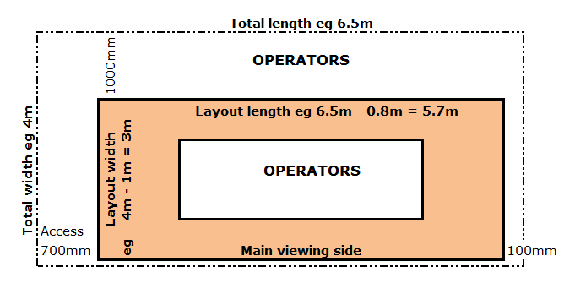

-------------------------------------------------------------------------------------------------------------------------------------------

Description of your Exhibit.

Please limit your description to not more than 200 words, and be aware that it may be necessary to edit your description to suit the Programme.

